Protocol Title

Investigator(s):

- Principal Investigator:
- Protocol Statistician (required for all interventional trials reviewed by the UF SRMC)
- Listing of any Co-Investigator(s):
- Primary Study Coordinator:
- Secondary Study Coordinator(s) (if applicable):

IRB of Record:

IRB #:

Coordinating Center (if applicable – multisite studies, only):

Study Sites (if applicable):

Study Sponsor:

Funding Source (if same as Sponsor, delete):

Protocol/Sponsor Number (if applicable):

Date of Original Protocol:

Date of Current Protocol:

Version of Current Protocol:

Abstract

If you are using this protocol template for your study document, the CPS Protocol Synopsis is optional. If you are using a different protocol template, the CPS Protocol Synopsis document is highly recommended. Additionally, if your grant abstract aligns with your protocol objects, you may include it with this document as an appendix item.

Protocol Synopsis
(see “Synopsis_CPS Interventional_TEMPLATE_CLEAN Draft_19May2020)

- Scientific Rationale and Background:

The purpose of this section is to explain how the protocol addresses the relevant scientific question(s) being asked. Also include the project’s likelihood for having a sustained, powerful influence on the research field(s) involved.

- Study Aims and Objectives:

The purpose of this section is to clearly define the objectives and endpoints of the protocol. For interventional protocols, explain how the objectives measure the impact of the proposed intervention.

- Primary Objective:
- Secondary Objective(s):
- Exploratory Objective (remove if not applicable):

- Study Schema (see example schema listed, below) and/or Schedule of events (if applicable):

The purpose of this section is two-fold: First, describe the methods of the protocol to adequately answer the questions addressed in the objectives. Discuss if there are adequate resources available within the UFHCC to conduct the study using the previously described methods. If applicable, for treatment intervention protocols, provide a description of the agent’s activity, dose delivery and scheduling, and dose modification criteria. Second, describe (using a bullet list or table/visual option) when each study procedure will be done and/or questionnaire or interview will be completed (baseline, 3-week f/u, final study visit, etc.). Note any biological Specimen collections or correlatives, and provide a description of collections, shipment, storage, etc. (if applicable).

STUDY SCHEMA EXAMPLE (Template can be provided via the CPS Navigator)
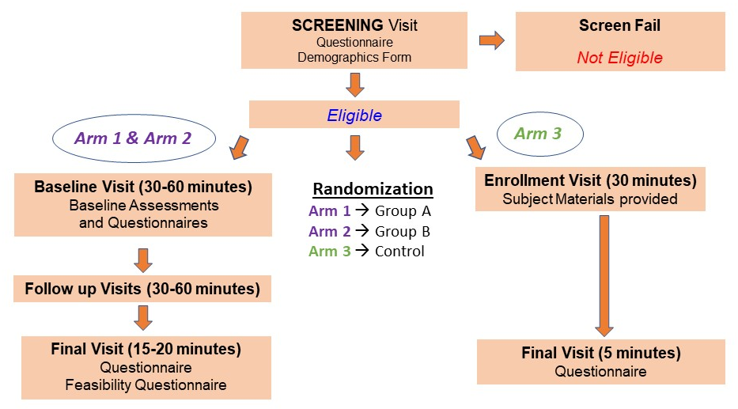

- Study Design:

In this section, explain the proposed protocol design (i.e. randomized, single-cohort, double-blind, etc.) and elaborate more on how the specific design will address the protocol’s objectives and scientific rationale. Discuss how the proposed objectives can be met with available resources (including those available through the UFHCC – if applicable) – and how they will be met within an acceptable time frame. If stopping rules should be included, include those, as well. Finally, describe the study relevance to the catchment area and address the potential for the study to accrue minorities and underrepresented populations (this could be included in the “Selection of Subjects” section, instead).

- Selection of Subjects:

This section should give a detailed description of: 1) the research subject population(s), 2) address eligibility requirements; and 3) explain the accrual goal and duration for the study. If subjects will be referred to study team and/or access via the clinic, this process – and note of key stakeholders in the process – should be explained. Additional considerations to include in inclusion/exclusion criteria may include: 1) patient disease group and response to intervention; 2) simultaneous participation in other protocols; and 3) other factors related to stratification or subject qualifications. All gender, employment, geographical, language, or other requirements must also be clearly stated and justified. If a study is multi-site, clarify if UF is serving as the coordinating center, or not, and the accrual goals for the other sites, as well.

- Total Number of Subjects (should be total of a + b):
  - Total Number of Subjects (affiliate sites, if applicable):
  - Total Number of Subjects (UF site):
- Key Inclusion Criteria:
- Key Exclusion Criteria:

V. Study Procedures:

Include all study related procedures including screening, pre-treatment, treatment, end of treatment and any follow-up, as applicable. Be sure to indicate what is done as part of normal care vs that of the research (e.g. dose specifications/calculations, any supportive care guidelines that will be followed, and/or behavioral interventions). Provide a clear and concise description of the treatment, intervention or observation to be carried out in the study. Clearly state the nature of the control (placebo, other intervention, historical) or the absence of a control (and justification) and any randomization procedures. Describe completely any special tests or procedures - such as surveys, questionnaires, and/or observations – that will be used to obtain information about the subjects. Describe who will be responsible for obtaining the information and in what type of setting the information will be obtained. Include names (and note about validation) of all questionnaires, data collection sheets, and/or case report forms. If applicable, also include a description of process for replacement of subjects who are withdrawn prior to completion and/or during screening procedures. Explicitly note any follow-up activities or procedures and the duration of each. Finally, include the procedures you will use to protect the privacy of subjects and ensure confidentiality of all data and study records including hard copy and computer files.

- Possible Discomforts and Risks:

The purpose of this section is to describe the discomforts and risks (physical, psychological, social, and/or economic) study participants may encounter, listing more common risks first and less common risks separately. If applicable, identify potential financial risks study participants may incur and indicate any procedures, medications, tests, or therapies that study participants (or their insurer) will have to pay for (if they are considered standard of care outside of the research procedures, describe this, as well). Additionally, describe procedures to protect against or minimize potential discomforts and
Risks.

Example wording may include:
- “These risks are considered to be minimal and are addressed in the protocol and consent form.”
- “Because <study procedure> can cause <risk>, <evaluation> will be monitored at frequent intervals during this part of the study and patients will be followed for a sufficient period of time after the procedure to ensure stabilization of <evaluation>.”
- “<Intervention> is commonly associated with <risks> and less commonly with other short- and long-term side effects, so patients will be monitored <interval> for expected and unexpected AEs related to <study procedure>.”

- Possible Benefits:

The purpose of this section is to describe the potential benefits to subjects or to others that may be reasonably expected to result from the research. If there is no potential for direct benefits, describe this in the protocol and ensure that it is stated in the Informed Consent Form, as well (contact the IRB for additional guidance). Discuss why the risks to subjects are reasonable in relation to the anticipated benefits and in relation to the importance of the knowledge that may reasonably be gained from completing this study, including how the research many benefit future populations.

VIII. Adverse Events/Unanticipated Problems:

The purpose of this section is to describe the process by which the Principal Investigator (PI) will show oversight and responsibility for determining whether observed AEs are expected or unexpected. An adverse event is considered unexpected if the nature, severity, or frequency of the event is not consistent with the risk information previously described for the intervention.

SUGGESTED WORDING FOR PROTOCOL DOCUMENT: All AEs, unanticipated problems and/or SAEs must be reported to the IRB of Record according to IRB’s policies and procedures for reporting serious adverse events. [insert specific sponsor requirements for reporting of SAEs including XX number of hours after becoming aware of the event and form completion requirements].

Additional information to consider when completing this section:
  - An adverse event (AE) is any untoward medical occurrence in a subject during participation in the clinical study or with use of the experimental agent being studied.
  - An adverse finding can include a sign, symptom, abnormal assessment (laboratory test value, vital signs, electrocardiogram finding, etc.), or any combination of these regardless of relationship to participation in the study.
  - The Office for Human Research Protections (OHRP) considers unanticipated problems involving risks to subjects or others to include, in general, any incident, experience, or outcome that meets all of the following criteria:
- Unexpected in terms of nature, severity, or frequency given (a) the research procedures that are described in the protocol-related documents, such as the IRB-approved research protocol and informed consent document; and (b) the characteristics of the subject population being studied;
- Related or possibly related to participation in the research (“possibly related” means there is a reasonable possibility that the incident, experience, or outcome may have been caused by the procedures involved in the research); and
- Suggests that the research places subjects or others at a greater risk of harm (including physical, psychological, economic, or social harm) than was previously known or recognized.

IX. Statistical Analysis Plan:

The purpose of this section is to ensure the statistical design for the study is clearly described, well-defined, and statistically sound. All accrual goals should be clearly stated, and the sample size should be adequate (and justified) to answer the specific objectives of the protocol. For qualitative studies, an appropriate analytical design and decision criteria should be included. Information to consider when completing this section includes:
- Sample size determination (including calculations or reflections for power and clinical justification)
- Analysis of primary endpoint, secondary endpoint(s), safety data, etc.
- Description of your plan for conducting an interim analysis
- Criteria for stopping rules that are in place (If applicable)
- Procedure for accounting for missing, unused, and spurious data
- Procedures for reporting any deviation(s) from the original statistical plan (any deviation(s) from the original statistical plan should be described and justified in protocol and/or in the final report, as appropriate).
- The selection of subjects to be included in the analyses (i.e. what makes a subject evaluable).

X. Study Monitoring

This section should clearly outline the Data Safety Monitoring Board (DSMB), Data Safety Monitoring Plan (DSMP) or the oversight committee for this research project. It is necessary to provide Information about the DSMB or committee including who is on the committee, how frequently the committee will meet, if there will be any planned interim analysis conducted and how (or if) any findings or recommendations will be provided.

XI. Data Integrity and Oversight:

The purpose of this section is to provide a description of how the PI will show personal responsibility for conducting and supervising the conduct of the human subjects who participate in this study. Described in this section should be the ethical manner – in accordance with all federal, state, and local laws and regulations, institutional policies, and the requirements of the IRB – by which the study will be managed and monitored.

Additional Information to include when completing this section:

Per UF IRB requirements, the PI is personally responsible for conducting and supervising the conduct of human subjects research by “protecting the rights, safety, and welfare of subjects under the investigator’s care.” The PI also must ensure that all the research conducted is done so in an ethical manner and in accordance with all federal, state, and local laws and regulations, institutional policies, and the requirements of the IRB.

Oversight is defined as “management by overseeing the performance or operation of a person or group; watchful care, superintendence, general supervision”. Any person serving as a PI has voluntarily accepted these responsibilities and is expected to fully comply with these requirements, as outlined in the UFHCC Guidance: Principal Investigator Responsibilities and Oversight.

The PI will be primarily responsible for continuous monitoring of adverse events, unanticipated problems, protocol violations, and other immediate protocol issues. The PI or their designee will collect information on subjects enrolled through the use of electronic or paper source documents, CRFs, and Informed Consent forms.

The Principal Investigator (PI) is responsible for ensuring the accuracy, completeness, legibility, and timeliness of the data reported. All source documents should be completed in a neat, legible manner to ensure accurate interpretation of data. The study team will maintain adequate case histories of study subjects, including accurate case report forms (CRFs), and source documentation.

INTERVENTIONAL studies MUST include the following information in the Data Integrity and Oversight section of the protocol.

If your study is NOT interventional, this section may be deleted. Please contact the CPS Navigator (UFHCC-CPSNavigator@cancer.ufl.edu) if you are unsure of your study’s designation type).

REQUIRED WORDING:

Data Integrity and Safety Committee

This protocol will be reviewed and monitored by the University of Florida Health Cancer Center Data Integrity and Safety Committee (UFHCC DISC) in accordance with their policies and procedures. They will review and monitor study progress, toxicity, safety and other data from this trial. Questions about subject safety or protocol performance will be addressed with the sponsor-investigator, statistician and study team members. Should any major concerns arise, the DISC will offer recommendations regarding whether or not to suspend the trial.

UFHCC DISC data and safety monitoring activities include:
- Review of clinical trial conducted for progress and safety
- Review of all adverse events requiring expedited reporting as defined in the protocol
- Review of reports generated by data quality control review process
- Notification of the sponsor-investigator of recommended action
- Notification of sites coordinated by the UFHCC of adverse events requiring expedited reporting and subsequent committee recommendations for study modifications

In compliance with the UFHCC data and safety monitoring plan, the PI will provide a Data Integrity and Safety Committee Report to DISC at the predetermined timelines for the level of risk category assigned during the initial SRMC (Scientific Review and Monitoring Committee) review, which occurs prior to initial IRB approval.

UFHCC investigator-initiated protocols will be classified into one of the following categories of risk by the SRMC (see SRMC manual for further details):

Level 1 – Low risk Investigator Initiated interventional trials.
Level 2 – Moderate risk Investigator Initiated or externally sponsored interventional (such as drug, biologic or device) trials using FDA approved or commercially available compounds or interventions.
Level 3 – High risk Investigator Initiated or externally sponsored interventional trials (such as investigator-sponsored INDs, Phase I trials, studies requiring biosafety approval, or other areas that may be designated by NIH as high risk).
Level 4 – Complex trials involving very high risk to subjects and a high level of complexity such as first in human or gene transfer studies.

The risk level assigned by SRMC will determine the appropriate level of DISC monitoring required, with increased monitoring required for higher-risk trials.

XII. Data Management:

Subject confidentiality is strictly held in trust by the investigators, study staff, and the sponsor(s) and their agents. This section should clarify the data management process to uphold that confidentiality – extending to cover testing of biological specimens (as applicable) – in addition to any study information relating to subjects. Authorized representatives of the sponsor may inspect all study documents and records required to be maintained by the investigator for the study subjects (this should be noted in the data integrity and oversight section and acknowledge in this section that the study site will permit access to such records in a safe and secure method.

XIII. Conflict of Interest:

Describe any conflict of interest relevant to this protocol. If none to note, please note “Not applicable”.
Appendices

Include copies of each instrument to be used, letters to potential participants or their physicians, as well as any other study materials to be seen by the participants and will be submitted with your protocol for IRB review and approval. These materials should also be submitted to SRMC if it will contribute towards the review.

