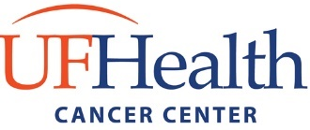

Team-based Interdisciplinary Cancer Research Training (TICaRT) Program

Research Team Information

The purpose of creating this list is to join you with others who are looking for a collaborator/team partner to apply for the TICaRT T32 Training Grant. Information surveys submitted will be added to our database and circulated to all the trainees seeking collaborators for team projects. Please plan to attend one of our Team Networking sessions to learn more about other trainees interested in our program.

Team Networking Sessions
* April 8, 2021 @ 4:00 PM, Zoom Link: https://ufl.zoom.us/j/93300887187
* April 22, 2021 @ 4:00 PM, Zoom Link: https://ufl.zoom.us/j/94850395201

CONTACT INFORMATION*
First |  | Last |  | UFID

Phone # |  | Email

ACADEMIC INFORMATION*

Academic Level of Training

(e.g., PhD candidate, MD-PhD, Postdoc, Resident, Clinical Fellow)

Academic Program |  | Major
Department |  | College

Primary Mentor/Research Lab

RESEARCH PROJECT INFORMATION*

Research Description

(What are your interests?)

Research Expertise

(What specialty you will contribute to the team?)

Potential Collaborator

(What are you looking for in a collaborator?)

I would like to share my information to other students interested in collaborating as a team* | YES |  | NO

