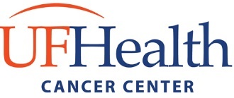

Team-based Interdisciplinary Cancer Research Training (TICaRT) Program

Research Team Information

The purpose of creating this list is to join you with others who are looking for a collaborator/team partner to apply for the TICaRT T32 Training Program. Information surveys submitted will be added to our database and circulated to all the trainees seeking collaborators for team projects. Please plan to attend one of our Networking sessions to learn more about other trainees interested in our program.

Networking Sessions
* November 17, 2023 @ 4:00 PM, CGRC CR-451
* January-March 2023 – Dates TBD

CONTACT INFORMATION*
First |  | Last |  | UFID

Phone # |  | Email

ACADEMIC INFORMATION*

Academic Level of Training

(e.g., PhD candidate, MD-PhD, Postdoc, Resident, Clinical Fellow)

Academic Program |  | Major
Department |  | College

Primary Mentor/Research Lab

RESEARCH PROJECT INFORMATION*

Research Description

(What are your interests?)

Research Expertise

(What specialty you will contribute to the team?)

Potential Collaborator

(What are you looking for in a collaborator?)

I would like to share my information to other students interested in collaborating as a team* | YES |  | NO

